**Operating Systems - Homework 2**  
- Multi-Threaded Word Count Program-

ChangYoon Lee

Dankook University, Korea Republic

32183641@gmail.com

**Abstract.** Most modern operating systems have extended the concept of the process to allow having multiple threads of execution and thus to perform more than one task at a time (*Silberschatz et al., 2014*). While allowing this multi-threaded concept, there are some issues to consider in designing it: Synchronization (Concurrency Control). In this paper, we will mainly discuss the concept of the multi-thread, synchronization examples, and their solutions, especially on producer and consumer problems. Also, we will implement the example case of producer and consumer problems with a multi-threaded word count program and evaluate it.

**Keywords:** Concurrency Control, Multi-Thread, Mutex, Producer and Consumer, Semaphore, Synchronization, Reader and Write,

# Introduction

Thread is a unit of execution. It has an execution context, which includes the registers, and stack. Denote that the address space in the memory is shared among the threads in the same process, so there is no clear separation and protection for the access of the memory space among the threads which are in the same process (Yoo, Mobile-os-DKU-cis-MSE). This single thread allows the process to perform only one task at a time. However, modern operating systems support the process to have multiple threads, so that they can execute multiple tasks parallelly at a time.

The concept of multi-threaded programming has some benefits, but there are some problems to be resolved to apply the following concepts, such as synchronization and deadlock. To resolve the following problem, we use several solutions such as queue, mutex, semaphore, and monitors, for the synchronization. For deadlocks, we can avoid them, or detect and resolve them.

In this paper, we will first explain the concepts of thread, multi-thread, problems along the multi-threaded programming and their solutions. By applying these concepts, we will explain how we implemented the multi-threaded word count program and its result for versions 1 through 3. At the end of the paper, we will present the execution time among the difference between the number of threads.

# Requirements

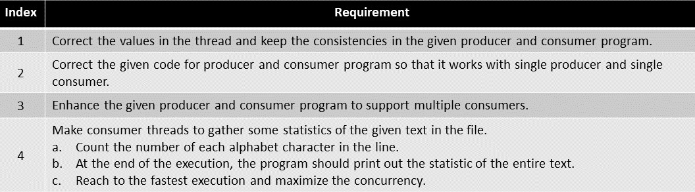

Figure 1 - Requirement Specification

Figure 1 shows the requirements for a multi-threaded word count program. The implementations for these requirements will be described in detail afterwards.

# Concepts

## Thread

The normal process model implies that a process is a program that performs a single thread of execution. For example, when a process is running a word-processor program, a single thread of the instructions is being executed. This single thread of control allows the process to perform only one task at a time (*Silberschatz et al., 2014*). On the systems that supports thread, the process control block (PCB) is expanded to include the information for the thread. Other changes throughout the system are also needed to support the threads.

## Multi-Thread

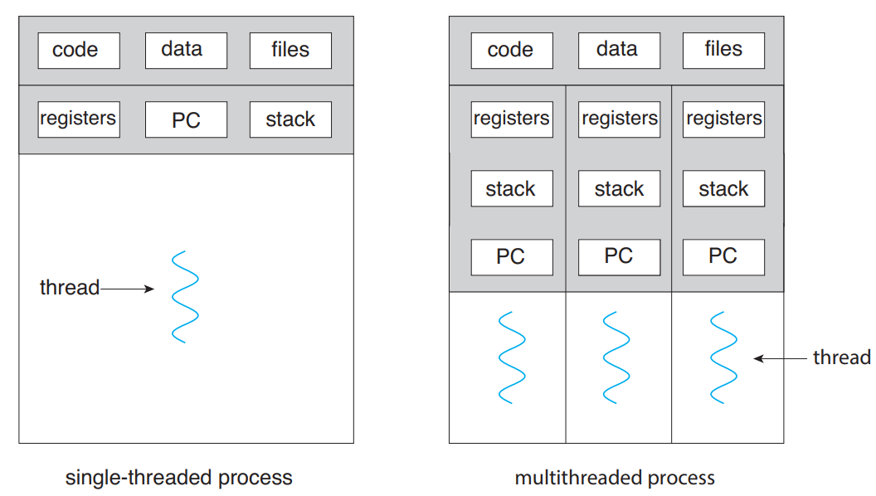

Figure 2 - Single-Threaded and Multi-Threaded Processes (*Silberschatz et al., 2014*)

As mentioned, a thread is a basic unit of CPU utilization, and most modern operating systems support the multi-thread for a single process. Also, modern software and applications run on multi-threaded devices. A single thread comprises a thread ID, a program counter (PC), a register set, and a stack. The concept of multi-thread uses multiple threads so that the program can execute multiple tasks parallelly at a time. Figure 2 shows the models of single-threaded and multi-threaded processes (*Silberschatz et al., 2014*).

The benefits of multi-threaded programming can be presented following categories:

* Responsiveness: Multithreading an interactive application may allow a program to continue running even if part of it is blocked or is performing a lengthy operation, thereby increasing responsiveness to the user.
* Resource Sharing: Processes can share resources only through techniques such as shared memory and message passing.
* Economy: Allocating memory and resources for process creation is costly. Because threads share the resources of the process to which they belong, it is more economical to create and context-switch threads.
* Scalability: The benefits of multithreading can be even greater in a multiprocessor architecture, where threads may be running in parallel on different processing cores.

Although multi-threaded programming has various advantages, there are also challenges in modifying multi-threaded programs. The challenges that must be resolved in multi-threading are presented in the following categories:

* Identifying Tasks: This involves examining applications to find areas that can be divided into separate, concurrent tasks.
* Balancing: While identifying tasks that can run in parallel, programmers must also ensure that the tasks perform equal work of equal value.
* Data Splitting: Just as applications are divided into separate tasks, the data accessed and manipulated by the tasks must be divided to run on separate cores.
* Data Dependency: The data accessed by the tasks must be examined for dependencies between two or more tasks. When one task depends on data from another, programmers must ensure that the execution of the tasks is synchronized to accommodate the data dependency
* Testing and Debugging: When a program is running in parallel on multiple cores, many different execution paths are possible

In this paper, we will focus on applying the concept of multi-threaded programming, and the solutions for resolving the presented challenges in the word count program.

## Synchronization

According to the concept of multi-threaded programming, data dependency can occur. By the data dependency, we would arrive at the incorrect state when the outcome of the execution depends on the particular order in which the access takes place. This situation is called a race condition. To avoid the following situation, we need to ensure that only one process at a time can manipulate the variable count.

Such situations occur frequently in the operating systems as different parts of the system manipulate the resources as multiple threads. As mentioned before, resolving the data dependency of multi-thread programming is an important challenge. Resolving the following situations is called synchronization and coordination among cooperating threads.

Each process and threads have a segment of code that accesses or updates the data that is shared with at least other processes or threads. These segmentations of code are called critical sections. One of the main situations in synchronization is protecting the access to the following critical section while one other process or thread is executing the codes that refer to the critical section, and this is called the critical-section problem.

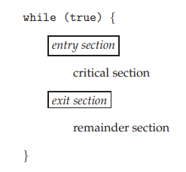

Figure 3 – General Structure of Typical Process (*Silberschatz et al., 2014*)

The critical-section problem is to design a protocol that the thread can use to synchronize their activity to cooperatively share the data. Figure 3 shows the general structure of the code in a process that is used to resolve the critical-section problem. Each thread must request permission to enter its critical section. The section of code that requests this permission is called the entry section. The critical section may be followed by an exit section. The remaining code is the remainder section. A solution to resolve the critical-section problem must contain the following three requirements:

* Mutual Exclusion: If one thread is executing its critical section, no other threads can execute their critical sections.
* Progress: If no process is executing in its critical section and some processes wish to enter their critical sections, then only those processes that are not executing in their remainder sections can participate in deciding which will enter its critical section next, and this selection cannot be postponed indefinitely
* Bounded Wait: There exists a bound, or limit, on the number of times that other processes are allowed to enter their critical sections after a process has made a request to enter its critical section and before that request is granted

There are several solutions for the following situation that satisfies the requirements above. In this paper, we will present two main solutions for resolving the critical-section problem, which is mutex and semaphore. The details of the mutex and semaphore will be presented in the later sections.

# Multi-Threaded Word Count Program

## Mutex

Operating system designers built higher-level software tools to solve the critical section problem. The simplest tool is the mutex lock. Mutex lock is used to protect the critical sections and prevent race conditions. This means that the thread must acquire the lock before entering a critical section, and releases the lock when it exits the critical section.

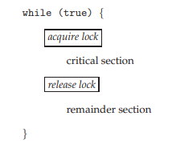

Figure 4 – Solving Critical-Section Problem by using Mutex Lock (*Silberschatz et al., 2014*)

Figure 4 shows the solution code that uses mutex lock to resolve the critical section problem. The acquire function acquires the lock, and the release function releases the lock. A mutex has a Boolean variable whose value indicates whether the lock is available or not. If the lock is available, the acquire function succeeds, and the lock is then considered to be unavailable. A thread that attempts to acquire an unavailable lock is blocked until the lock is released.

The main disadvantage of the implementation of the mutex lock is that it acquires busy waiting. While a process or thread is in its critical section, any other process that tries to enter its critical section must loop continuously in the call of acquiring function. This continual looping becomes a problem in the multi-programming system because it wastes the CPU cycle that some other processes and threads might be able to use productively. In the aspect of continuously looping for the busy wait, the mutex lock is also called a spin-lock because the thread spins while waiting for the lock to become available.

## Semaphore

A semaphore is an integer variable that is accessed only through two standard atomic operations, which are waiting and signal functions. When one thread modifies the semaphore value, no other thread can simultaneously modify that same semaphore value. Also, in the case of the wait function, the testing for value whether the semaphore is less than zero or not must be executed without interruption.

Operating systems often distinguish the semaphores between counting and binary semaphores. The value of a counting semaphore can range over an unlimited value. However, the value of a binary semaphore can range only between zero and one. Therefore, the binary semaphores act similarly to mutex locks.

Counting semaphores can be used to control the access to given resources that are consisted of a finite number of instances. This semaphore is initialized to the number of available resources. Each thread that needs to use a resource performs the wait function on the semaphore. When a thread releases a resource, it performs a signal function. If the count of the semaphore goes to zero, all resources are being used. After that, threads that wish to use a resource will block until the count of the semaphore becomes greater than zero.

By using the semaphore, we can resolve the various synchronization problems. One of the well-known problems in synchronization is the producer and consumer problem. The details and implemented solutions for the following problem will be discussed in the later sections.

## Producer and Consumer Problem

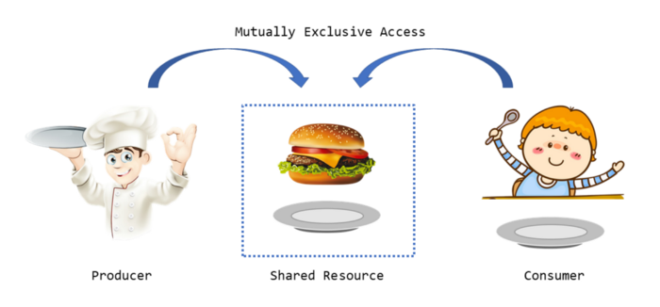

Figure 5 – Producer and Consumer (*Yan, 2020*)

The common concept of the cooperating processes or threads is the producer and consumer problem. A producer thread produces information that is consumed by a consumer thread. For example, a compiler may produce the assembly code that is consumed by an assembler.

One solution to the producer and consumer problem is using shared memory. To allow producer and consumer threads to run concurrently, the computer must have the available buffer of items that can be filled by the producer and emptied by the consumer. A producer can produce the item while the consumer is consuming another item. The producer and consumer threads must be synchronized so that the consumer does not try to consume an item that has not been produced.

There can be two types of buffers, which are unbounded and bounded. The unbounded buffer places no practical limit on the size of the buffer. The consumer may have to wait for the new item, but the producer can always produce the new items. However, for the bounded buffer, because it assumes the fixed size buffer, the consumer must wait for the buffer is empty and the producer must wait if the buffer is full.

One issue in the bounded buffer producer and consumer situation concerns the situation that both the producer and consumer threads attempt to access the shared buffer concurrently. To reach the concurrency of the producer and consumer threads, we can use semaphore and mutex.

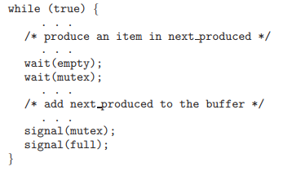

Figure 6 – The structure of the producer process (*Silberschatz et al., 2014*)

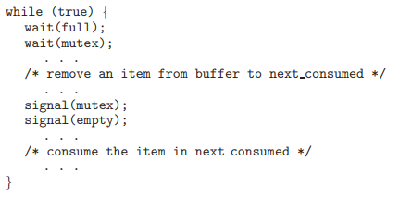

Figure 7 – Solving Critical-Section Problem by using Mutex Lock (*Silberschatz et al., 2014*)

Figure 6 and 7 shows the code for the producer and consumer threads. Note the symmetry between the producer and the consumer. We can interpret the following code as the producer producing the full buffer for the consumer or as the consumer producing empty buffers for the producer.

The following problems will be also presented in the implantation of a multi-threaded word count program. By applying the code presented in Figures 6 and 7, we will state the problem that occurs while implanting the following program and explain how we solved the problem by using mutex and semaphore.

## POSIX Synchronization - Mutex

The POSIX API allows the programmers at the user level to proceed with sections that pertain to synchronization. The following API is not part of any particular operating system kernel, so it can be used widely along any operating system.

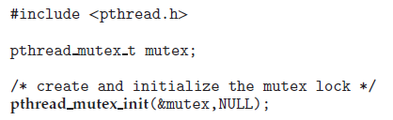

Figure 7 – pthread_mutex_init function (*Silberschatz et al., 2014*)

Mutex locks represent the fundamental synchronization technique used with the Pthreads. Pthreads uses the pthread_mutex_t data type for mutex lock. A mutex is created with the pthread_mutex_init function. The first parameter is a pointer to the mutex. By passing NULL as a second parameter, we can initialize the mutex to its default attributes. Figure 7 shows the code for the following data type and function.

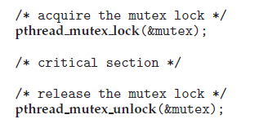

Figure 8 – pthread_mutex_lock and pthread_mutex_unlock functions (*Silberschatz et al., 2014*)

The mutex is acquired and released with the pthread_mutex_lock and pthread_mutex_unklock functions. If the mutex lock is unavailable when the pthread_mutex_lock function is invoked, the calling thread is blocked until the owner invokes the pthread_mutex_unlock. Figure 8 shows the code for the following functions.

## POSIX Synchronization - Semaphore

POSIX system also provides the semaphores, although semaphores are not part of the POSIX standard and instead belong to the POSIX SEM extension. POSIX specifies two types of semaphores, which are named and unnamed semaphores. In this paper, we will only explain the named semaphore.

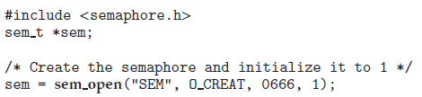

Figure 9 – sem_open function (*Silberschatz et al., 2014*)

The function sem_open is used to create and open a POSIX named semaphore. Figure 9 shows the code for the following function. The advantage of the named semaphore is that multiple unrelated threads can easily use a common semaphore as a synchronization mechanism by simply referring to the semaphore’s name.

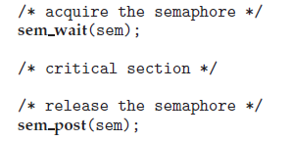

Figure 10 – sem_wait and sem_post functions (*Silberschatz et al., 2014*)

Figure 10 shows the code for sem_wait and sem_post functions. Which takes the role of the semaphore’s signal and wait for operation which is presented in the previous section. Both LINUX and macOS systems provide the POSIX named semaphores.

## POSIX Synchronization – Condition Variable

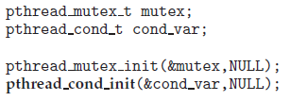

Figure 11 – ptheard_cond_t data type and pthread_cond_init function (*Silberschatz et al., 2014*)

Condition variables in Pthreads provide a locking mechanism to ensure data integrity. Condition variables in Pthreads use the pthread_cond_t data type and are initialized by the pthread_cond_init function. Figure 11 shows the code of the following data type and function.

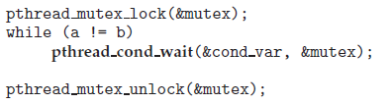

Figure 12 – pthread_cond_wait function (*Silberschatz et al., 2014*)

The pthread_cond_wait function is used for waiting on a condition variable. The code presented in Figure 12 shows how a thread can wait for the following condition to become true using a Pthreads condition variable. The mutex lock associated with the condition variable must be locked before the pthread_cond_wait function is called since it is used to protect the data in the conditional clause from a possible race condition.

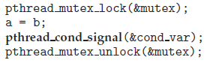

Figure 12 – pthread_cond_signal function (*Silberschatz et al., 2014*)

A thread that modifies the sheared data can invoke the pthread_cond_signal function to return the conditional variable. Figure 13 shows the code of the following function. It is important to note that the call to the pthread_cond_signal does not release the mutex lock. Once the mutex lock is released, the signaled thread becomes the owner of the mutex lock and returns the control from the call to the pthread_cond_wait function.

## Program Definition

Before implementing the multi-threaded word count program, we will state the additional program definition that will be used in the real implementation.

* Global Variables

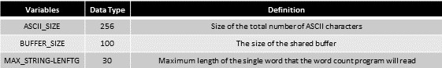

* Modules and Functions



# Implementation

## Producer and Consumer Version 1

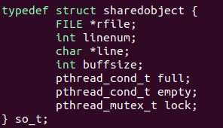

Figure 13 – Structure of the Shared Buffer of the Program ‘Producer and Consumer Version 1’

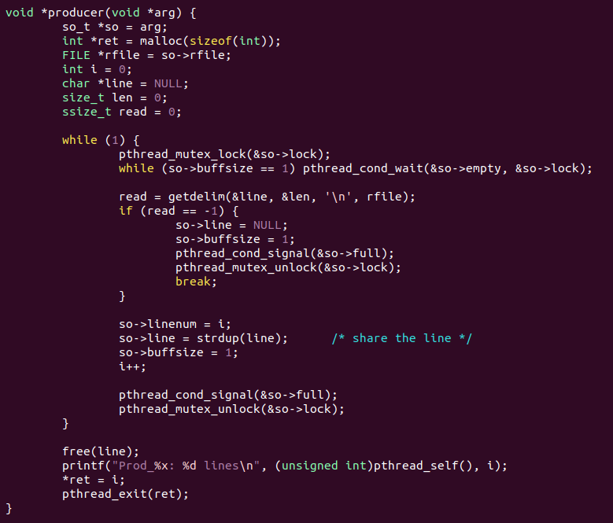

Figure 14 – Code for Producer Thread of the Program ‘Producer and Consumer Version 1’

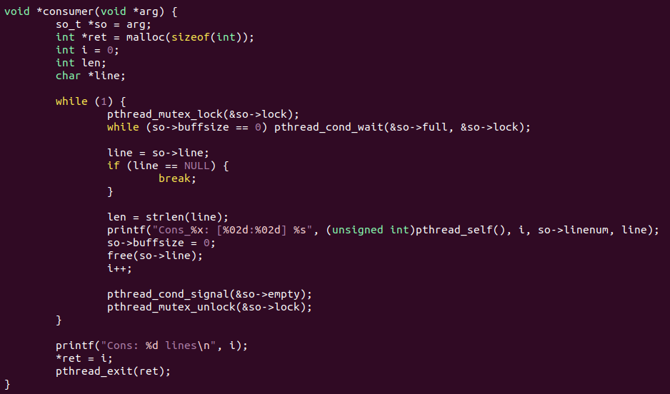

Figure 15 – Code for Consumer Thread of the Program ‘Producer and Consumer Version 1’

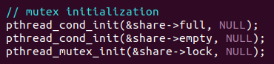

Figure 16 – Initialization of the mutexes used in the Program ‘Producer and Consumer Version 1’

The program ‘producer and consumer version 1’ is mainly focused on solving the producer and consumer problem for a single producer and a single consumer. To reach the following problem, we used two pthread_cond_t variables, full and empty, and one pthread_mutex_t variable, which is a lock. Figure 13 to 16 shows the implemented code of the program ‘producer and consumer version 1’.

Each code of the producer and consumer thread follows the operation flow which is presented in section 4.3. In the producer thread, it first acquires the mutex lock to get into its critical section. Then, after getting the buffer empty signal, it processes the critical section by filling the produced data into the shared buffer and unlocking the lock and full to signal that the consumer thread can get into its critical section. In the consume thread, it acquires the mutex lock to get into its critical section and consumes the data in the shared buffer. Then, it unlocks the lock and empties it to signal that the producer thread can get into its critical section. In short, the lock mutex limits the accessibility to the shared buffer, and full and empty mutex synchronizes the execution of the prouder thread and the consumer thread.

The following program executes successfully on the single producer and single consumer cases. However, it still has the limitation on executing single producers and multiple consumers, multiple producers, and single consumers, and multiple producers and multiple consumers.

## Producer and Consumer Version 2

Figure 17 – Structure of the Shared Buffer of the Program ‘Producer and Consumer Version 2’

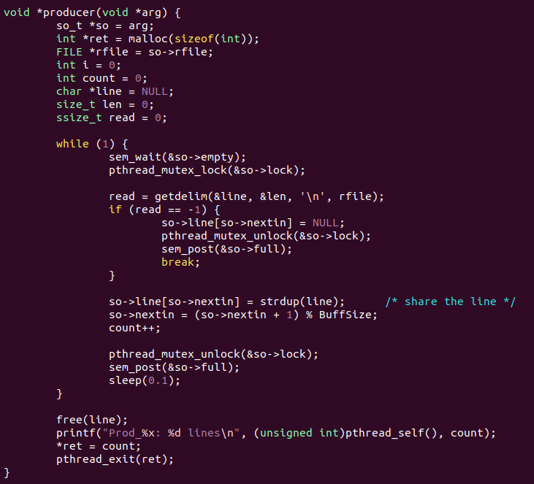

Figure 18 – Code for Producer Thread of the Program ‘Producer and Consumer Version 2’

Figure 19 – Code for Consumer Thread of the Program ‘Producer and Consumer Version 2’

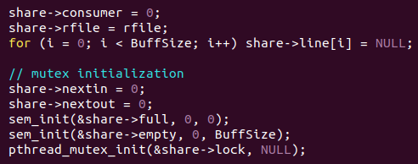

Figure 20 – Initialization of the mutexes used in the Program ‘Producer and Consumer Version 2’

The limitation of the program ‘producer and consumer version 1’ is that it can only be executed in the single producer and single consumer condition. The program ‘producer and consumer version 2’ is mainly focused on solving the following limitation. To reach the following problem, we changed the previous pthread_cond_t variable into the semaphores, full and empty. Also, we changed the string variable into the list of the string and added new variables, next in and next out, to point out the current index that the producer and consumer are producing and consuming the data in the array. Figure 17 to 20 shows the implemented code of the program ‘producer and consumer version 2’.

Since we changed the conditional mutexes into the semaphores, we no longer use the while loop for the conditional statement, but we use the wait function of the semaphores. One of the problems while implementing the following program was the termination operation of the consumer threads. After the termination of the first consumer thread, other consumer threads wait for the full semaphore to be filled, and as a result, the program cannot terminate its execution. To solve this problem, we added an operation at the termination of the consumer threads. In Figure 19, we can check the orange box that denotes the post signal of the full semaphore. By signaling the full semaphore for every single consumer thread, we can cascade terminate the consumer threads.

Also, initializing the semaphores in the proper value is important to work to be done. As we mentioned in section 4.5, we can initialize our semaphores by using the sem_init function. The important thing is that the empty semaphore should be initialized so that it could be increased to the shared buffer size and the full semaphore is initialized to be the conditional semaphore. The reason why is that the producer can produce the item until the shared buffer is fully charged, but the consumer can only consume the item when the shared buffer is not empty. Therefore, the full semaphore should be set as a conditional semaphore.

## Producer and Consumer Version 3

Figure 21 – Counting Word for its Length and the Starting Character in the Consumer Thread

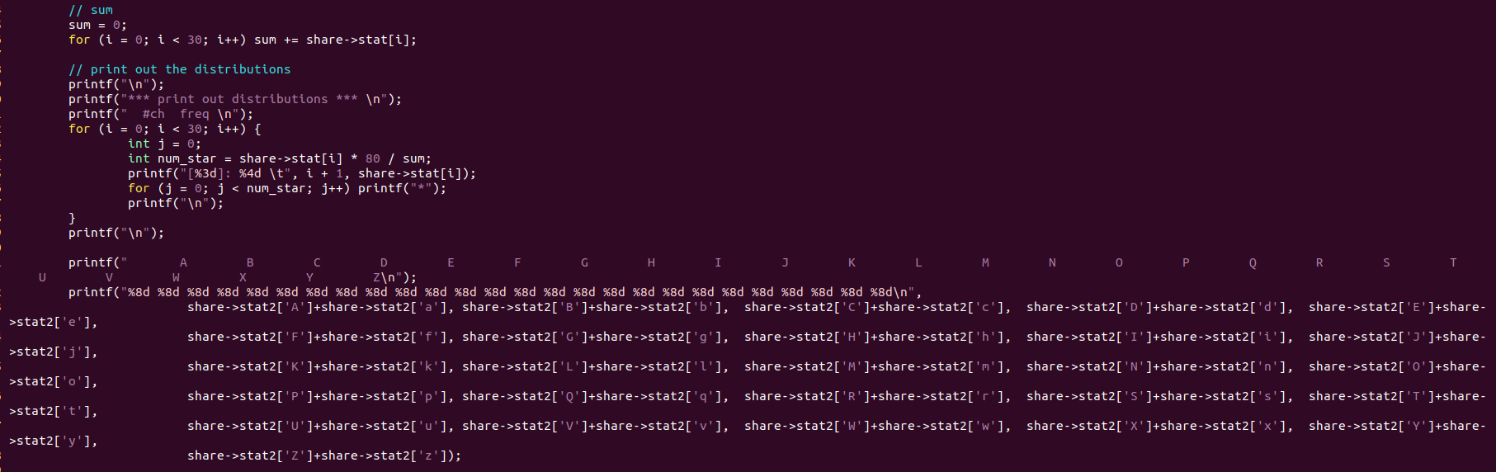

Figure 22 – Printing Out the Counted Result in the Main Thread

The program ‘producer and consumer version 3’ is printing out the word count result from the read text file. To reach the following problem, add the code, which is implemented in the consumer thread, that counts the length of the line from the text file and the code counts the starting character of the word from the text file. Also, the code that prints out the counted results is implemented in the main thread. Figure 21 and 22 shows the implemented code of the program ‘producer and consumer version 3’.

# Build Environment

Following build environments are required to execute the multi-threaded word count program.

* Build Environment:

1. Linux Environment -> Vi editor, GCC Complier
2. Program is built by using the LINUX Shell.

* Build Command:

1. $gcc -O2 -pthread prod_cons_v1.c -o prod_cons_v1   
   -> build the execution program of producer and consumer version 1 program.
2. $gcc -O2 -pthread prod_cons_v2.c -o prod_cons_v2   
   -> build the execution program of producer and consumer version 1 program.
3. $gcc -O2 -pthread prod_cons_v3.c -o prod_cons_v3   
   -> build the execution program of producer and consumer version 1 program.

* Execution Command:

1. ./prod_cons_v1 {$readfile}   
   -> Execute the producer and consumer version 1 program.
2. ./prod_cons_v2 {$readfile} #Producer #Consumer  
   -> Execute the producer and consumer version 2 program.
3. ./prod_cons_v3 {$readfile} #Producer #Consumer  
   -> Execute the producer and consumer version 3 program.

# Results

* Producer and Consumer Version 1 reading LICENSE file.

* Producer and Consumer Version 2 reading LICENSE file with two producer threads and one consumer thread.

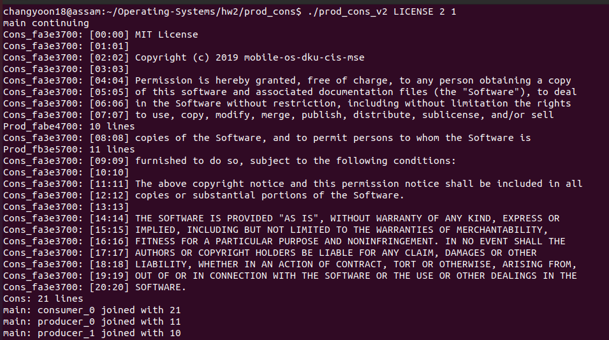

* Producer and Consumer Version 2 reading LICENSE file with one producer threads and two consumer thread.

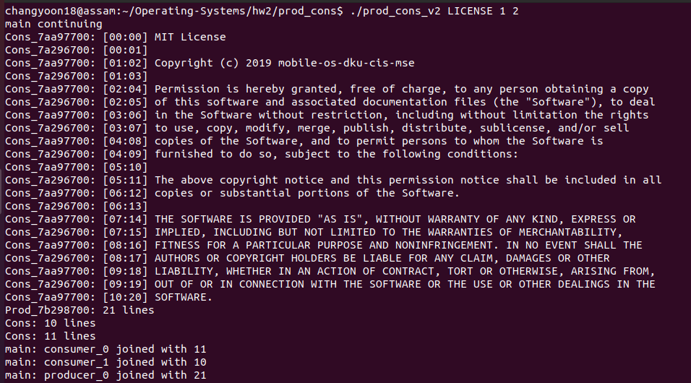

* Producer and Consumer Version 3 reading LICENSE file.

* Reading FreeBSD9-orig/ObsoleteFiles.inc with Producer and Consumer Version 3 by using numerous producer and consumer threads from one to ten.

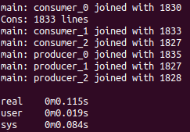

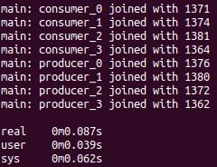

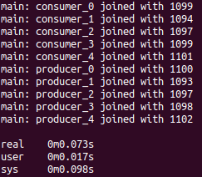 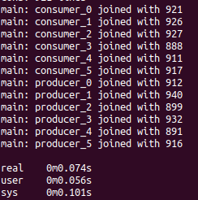

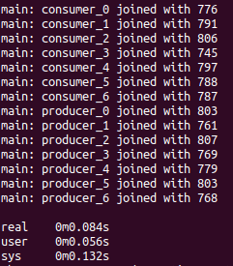 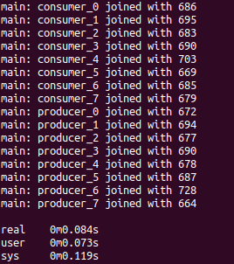

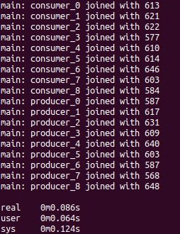 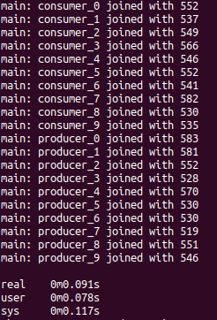

# Evaluation

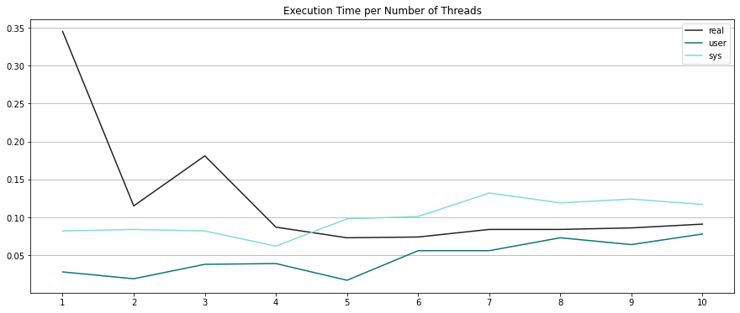

Figure 23 – Graph of the Execution Time per Number of Threads for Multi-Threaded Word Count Program

Figure 23 shows the graph result of execution time per number of the threads for the producer and consumer version 3 program that reads the file of FeeBSD9-Orig/ObsoleteFiles.inc. There are three main graphs in the following figure: real, user, and system. The main graph that we must focus on is the real execution time. As the number of threads is increased, the real execution time of the following program decreases when the number of the producer and consumer threads is increased. In short, as the number of threads in the single process increases, the execution time will decrease, which also means that the performance increases due to the increment of the number of threads. This result proves that the advantages of using multi-thread programming are economy and scalability.

# Conclusion

In this paper, we will first explain the concepts of thread, multi-thread, problems along the multi-threaded programming, and their solutions. By applying these concepts, we will explain how we implemented the multi-threaded word count program and its results for versions 1 through 3. At the end of the paper, we will present the execution time among the differences between the number of threads.

Multi-thread programming is the ability of a program or an operating system to enable more than one user at a time without requiring multiple copies of the program to run on the computer. Multi-thread programming can also handle multiple requests from the same user (Kirvan, 2022). One of the main problems that should be considered in applying multi-thread programming is handling the data dependency among the threads. The data accessed by the tasks must be examined for the data dependency on the shared data from other threads. Therefore, we must deal with this data dependency with synchronization along the different threads.

In this paper, we have explained the concept of the thread, multi-thread, and the synchronization of the threads. Then, we discussed the synchronization tools for multi-thread programming, which are applied to the multi-threaded word count program that we have implemented. We looked over the mutex, semaphore, and the most common cause of the synchronization problem, which is the producer and consumer problem. Due to the building environment that we have used, we explained the synchronization tools of the POSIX environment. From the first requirement to the third requirement, we implemented multiple versions of the multi-threaded word count program that fits each requirement. The first version was for single producers and single consumer cases. The second version was for multiple producers and multiple consumers. The third version was the complete program that has the character count operations in addition to the second version of the program. At the end of this paper, we evaluated the performance among the different number of threads for the execution of a multi-threaded word count program. As a result, we found out that the performance of the multi-threaded program increases when the number of threads for the following program increases.

By understanding this paper, we can understand the basic concepts of thread and multi-threaded programming. Also, we can understand the problems and the solutions that occur by applying the following concept, which is mainly about data dependency and synchronization.

# Citations

[1] Kirvan, P. (2022, May 26). *What is multithreading?* WhatIs.com. Retrieved September 11, 2022, from [https://www.techtarget.com/whatis/definition/multithreading](https://www.techtarget.com/whatis/definition/multithreading%20)

[2] Silberschatz, A., Galvin, P. B., &amp; Gagne, G. (2014). 2.2.1 Command Interpreters. In Operating Systems Concepts. essay, Wiley.

[3] Yan, D. (2020, December 22). *Producer-consumer problem using mutex in C++*. Medium. Retrieved September 9, 2022, from [https://levelup.gitconnected.com/producer-consumer-problem-using-mutex-in-c-764865c47483](https://levelup.gitconnected.com/producer-consumer-problem-using-mutex-in-c-764865c47483%20)

[4] Yoo, S. H. (n.d.). Mobile-os-DKU-cis-MSE. GitHub. Retrieved September 8, 2022, from <https://github.com/mobile-os-dku-cis-mse/>